ETHNIC GROCERY STORE TRIP
Name:
Institution:

ETHNIC GROCERY STORE TRIP
An ethnic grocery store comprises of supermarkets that sell food items that are distinctively cultural that specifically originate from immigrant populations. My experience of visiting an ethnic store was fascinating because product prices are cheaper. The unusual product I came across in the store I visited was bananas and avocado. Usually, the common products aisles entail seafood department, beer and wine section and meat department. Not even once have I come across unripe bananas and ripe avocados in the ethnic grocery stores have been to. It was amusing to know that the two can be consumed together as explained by the store managers. The bananas are to be cooked and the avocado is to be added on top when the bananas are ready. I also discovered that the type of bananas come from a culturally diverse communities in Africa such as Uganda.
Other nine items that were not familiar to me were, Yams that usually grow along swampy river banks and are peeled and then mostly consumed with tea. Other products that were native included fruits like black eyed pea and Oryza glaberrima. Cassava was also present in the shelves and can be consumed either on its own through boiling or by mixing with any good stew. Another shelf line had native vegetables like African black nightshade, spider-plant, pumpkin and amaranth which are simply boiled to make soup. Surprisingly, the demand for such items is higher representing higher industry sales for consumers aged 25 to 34 years old (Khojasteh & Raja, 2017). I also learnt that it is wise to seek recommendations before settling for any of these items.
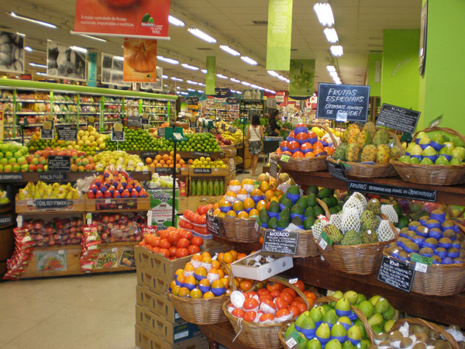
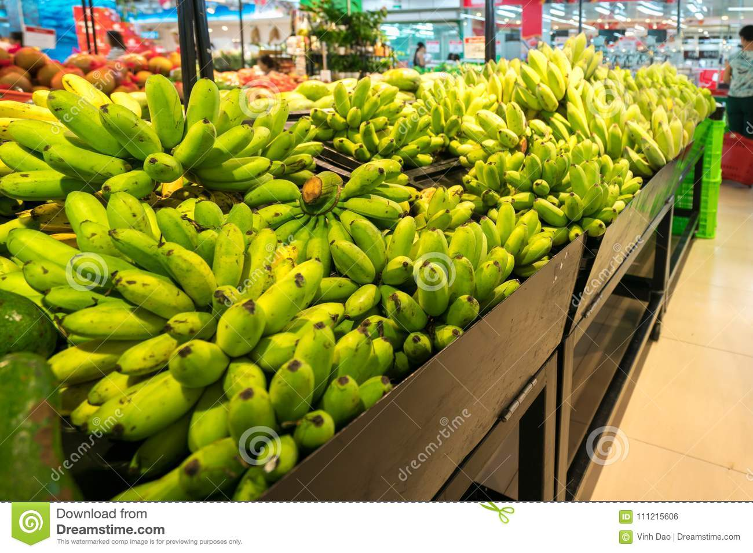
In regard to these products it is noticeable that these grocery stores play a very essential role by providing co-ethics services that offer immigrants job opportunities and a feeling of belonging (Wang & Lo, 2007).
Conclusion
In summary, it is therefore evident that not only are ethnic grocery stores limited to immigrants but also to all other ethnic groups because the products are believed to be highly nutritious. As illustrated above, the demand for such items is higher representing higher industry sales for consumers aged 25 to 34 years old. On the contrary old aged individuals should consider these items more than processed foods because they are highly nutritious.

References
Wang, L., & Lo, L. (2007). Immigrant grocery-shopping behavior: Ethnic identity versus accessibility. Environment and Planning A, 39(3), 684-699.
Khojasteh, M., & Raja, S. (2017). Agents of change: how immigrant-run ethnic food retailers improve food environments. Journal of Hunger & Environmental Nutrition, 12(3), 299-327.

